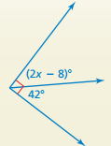
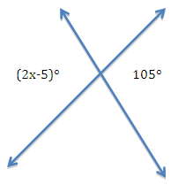
1) 2)

3) Two angles are supplementary. If Angle 1 is 75°, what is the measure of Angle 2?

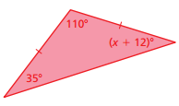
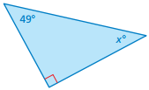
Find the value of x. Then classify the triangle.
4) 5)

Find the value of x.
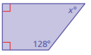
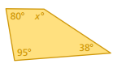
6) 7)

8) Classify the quadrilaterals:
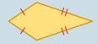
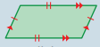
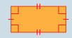
a) b) c)

d) Which three quadrilaterals have exactly two different pairs of congruent sides?

9) Find the diameter of a circle with the given radius:
a) 1 inch b) 20 feet

10) Find the radius of a circle with the given diameter:
a) 60 millimeters b) 3 yards

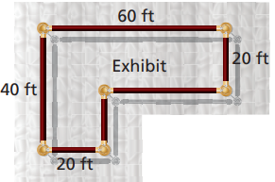
Find the PERIMETER of the given figure. Show formula work.
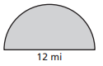
11) 12)

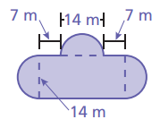
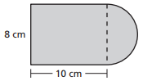
13) 14)

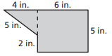
Find the AREA of the given figure. Show formula work.
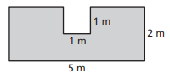
15) 16)

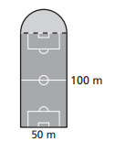
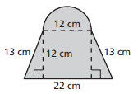
17) 18)

