Practice Quiz: 6.1 – 6.4

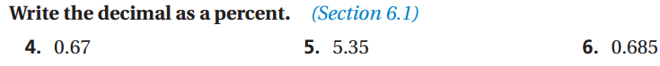

Convert to same form. Then, circle the greater number. (Section 6.2)

Convert to same form. Then order from least to greatest. (Section 6.2)

