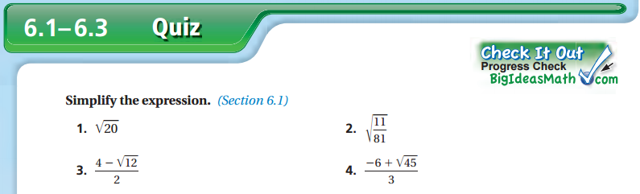
Name: ________________________________________ Period: ________ Date: _______
