Name: _______________________________________________ Date: __________________
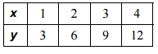
Review: 5.1 – 5.4 Rates, Ratios, Proportions
1) Is the table proportional or not? Why?
If so, what is the Constant of Proportionality?
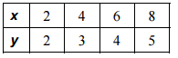
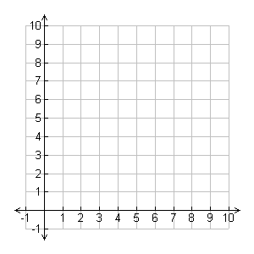
2) Graph the values on the coordinate plane below.
Is the graph proportional or not? Why?
If so, what is the Constant of Proportionality?

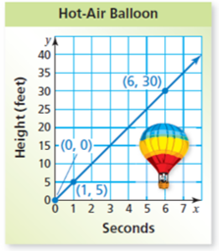
3) Interpret each plotted point in the graph below.

4) Write the ratio as a fraction in simplest form:

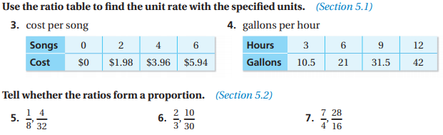

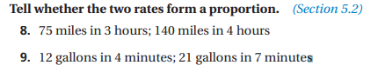

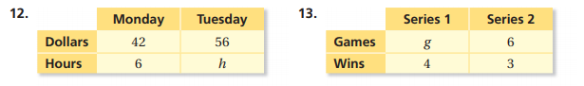
Write a proportion with units from the table:

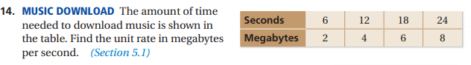

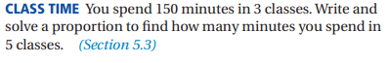
15. Write and solve a proportion with units:

16. Write and solve a proportion with units:
Michelle reads 34 pages in 20 minutes. How many minutes does it take her to read 115 pages?

17. Solve using cross-products: a) $\frac{13}{24}=\frac{30}{x}$ b) $\frac{x-7}{3}=\frac{12}{25}$

