Create mapping diagrams for the relations below. Is the relation a function? Explain why or why not.

________________________________________ ______________________________________________
Is the relation a function? Explain why or why not.

________________________________________ ______________________________________________

5. A relation is a set of points. _________________________________________________________________
6. Every set of points is a function. _____________________________________________________________

Do the following graphs represent functions? Why or why not?

________________________________________ ______________________________________________

10. Do the following functions have discrete or continuous domains? Explain your reasoning.

_________________________________________________________________________________

_________________________________________________________________________________

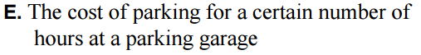
_________________________________________________________________________________

_________________________________________________________________________________

Describe the domain and range of the functions. Is the domain discrete or continuous?
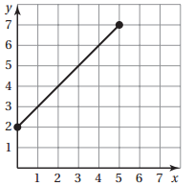
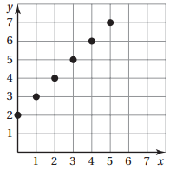
11. 12.

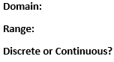
Domain:
Range:
Discrete or Continuous?

