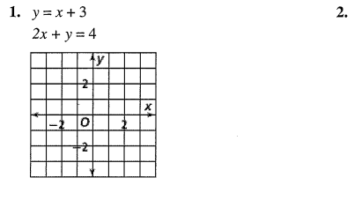
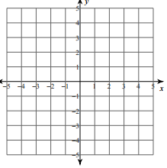
Solve by graphing. List your solution. Do NOT transform standard form.
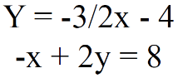

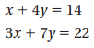
Solve the systems of linear equations by substitution. Show your work. 3)

Solve the system of linear equations by elimination. Show your work.
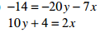
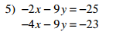
6)

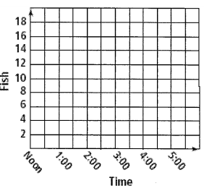
7) Two fisherman go ice fishing. At noon, fisherman A has 6 fish and is catching 2 fish per hour. Fisherman B has 4 fish at noon and is catching 3 per hour.
a. Define your variables and write a system of equations that relates the time to the total fish caught.

b. Graph the system of equations.
c. At what time will they have the same number of fish?

d. At that time, how many fish will they each have?
Use a system to model the situation. Solve by any method (you may use a calculator if needed!).
8) At the fair, you buy 3 sausage sandwiches and a milkshake and it costs you $8.25. Your friend buys 1 sausage sandwich and 2 milkshakes and her total is $5.25. What is the cost of one sandwich and one milkshake?

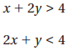
Graph the system of linear inequalities. Graph from Standard Form without transforming!
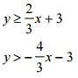
9) 10)
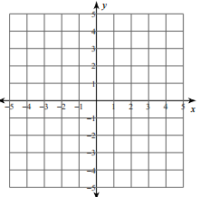

One solution? ______ One solution? ______

11) You have $90 to spend at the mall. You want to buy at most 6 articles of clothing. A clothing store sells shirts for $12 and pairs of pants for $18.
a) Define your variables and write a system of inequalities for this situation.

b) Graph the system. Label your axis.

c) What are two possible solutions for the situation?

