1. Graph the inequalities on the number line given:
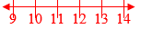
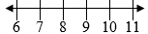
a) x < 8 b) x ≥ 10

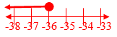
2. Write out the inequality shown on the number lines below:
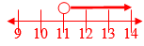
a) _____________ b) ______________

3. Solve and graph the inequalities given. Show all work for full credit:
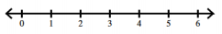
a) b) 26 < 23 + v

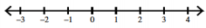

4. Solve and graph the inequalities given. Show all work for full credit:
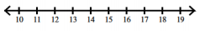
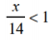
a) b) -8x ≥ 48

5. Is the given value a solution of the inequality? Show substitution work and write “yes” or “no”.
a) x – 2 ≥ -1; x = 8 b) -2c < 9 + c; c = -20

6. Write the word sentence as an inequality. Don’t solve.
The difference of -3.6 and a number x is less than 6.5.

7. Write an inequality that represents this situation. Let x represent age.
A person who is at least 65 years old is often considered a senior citizen.

