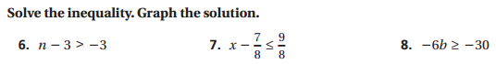
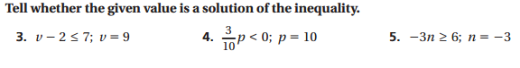
Show substitution work!
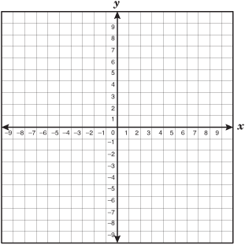
17. y > -3x + 4
TP
TP

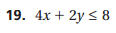
TP
TP

Write an inequality for each situation. Define your variable(s). Solve the inequality. Show algebra work!
