Slope/Slope-Intercept Form Quiz Review (2.1, 2.2, 2.3, 2.5) Name:
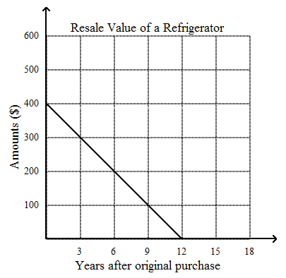
Rate of change: The rate of change is constant in each table or graph. Find the rate of change for each situation. Don’t forget units!
Time (days) | Cost ($)
3 | 75
4 | 100
5 | 125
6 | 150
1. 2.

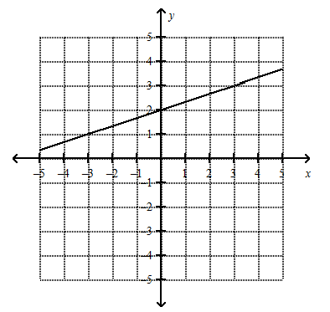
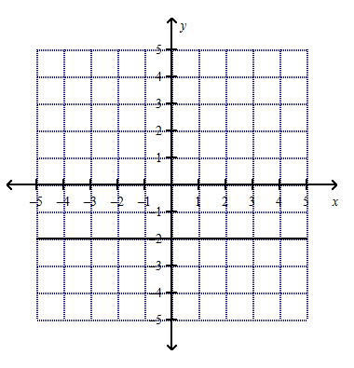
Slope: Find the slope of the line.
3. 4.

**What is the slope of a line that is parallel to #3? ________ Perpendicular? __________

Find the slope of the line that goes through the following points:
5. (1, 7), (10, 1) 6. (-3, 4), (-4, -6)

Identify the slope and y-intercept of the line:
7. 4x – 3y = 9 8. $y-3=-\frac{2}{5}(x+5)$

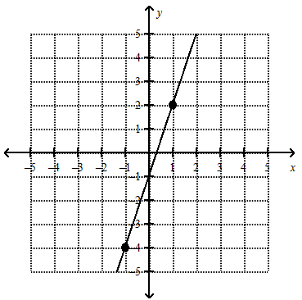
9. Write an equation for the line in slope-intercept form:

10. Graph using a table: $y=\frac{3}{4}x-3$
x | $$y=\frac{3}{4}x-3$$ | y | (x,y)

11. Graph the equation using slope and y-intercept. No table! y = $-\frac{2}{5}x+1$
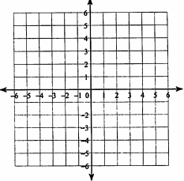

12. Suppose a town has a population of 5,000 residents but that the population is decreasing by 200 people each year.
a) Define variables for this situation.

b) Write an equation in slope-intercept form.

c) Use your equation to find how many people live in the town after 11.5 years.

13. Is the point (-8, 3) a solution to the equation y = -2x – 19? Show math evidence.

