Name Date

Practice Quiz: Chapter 2 Quiz 2.1-2.3

Write the fraction or mixed number as a decimal.

1.  2. 

Write the decimal as a fraction or mixed number in simplest form.

3.  4. 

Complete the statement using  Show your thinking!

5.    6. 

**Order the numbers from least to greatest using the number line below.**

**7. $2.1, -\frac{6}{10}, -\frac{9}{4}, 0.75, \frac{5}{3}$**



Order from least to greatest: ________________________________________________

**8.** -3.1 + 0.35 **9**. 12.48 - (-10.636)

**10**. -10.9 + (-15.6) - 2.1

**11. 12. $2\frac{1}{6}-(-\frac{8}{3})$**

**13. $-\frac{13}{6}+\frac{7}{12}-(-\frac{1}{6})$**

**14.** A parasail is at 200.6 feet above the water. After 5 minutes, the parasail is at 120.8 feet above the water. What is the change in height of the parasail?

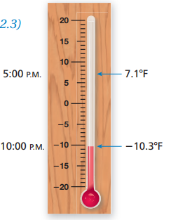**15.** Use the thermometer shown. How much did the temperature drop from 5:00pm to 10:00pm?