Name: _________________________________________ Period: _____ Date: _________
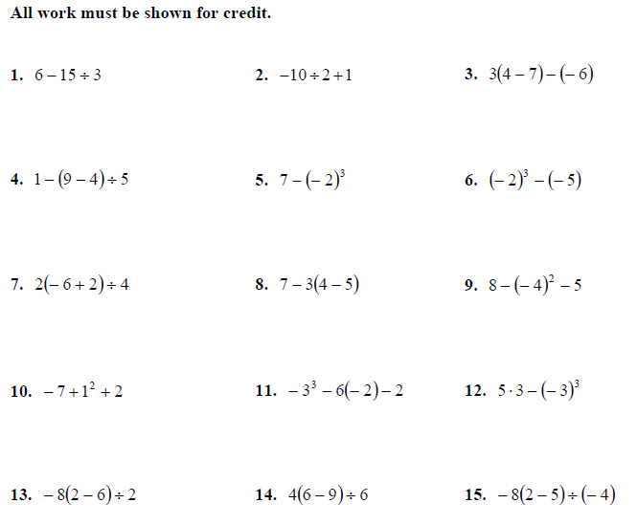
Order of Operations with Integers
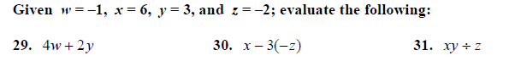

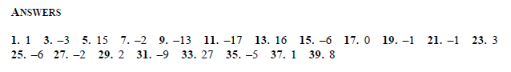

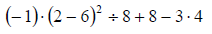
Challenge:

