For each problem below, write an equation and then solve. Some equations may be one-step, some will be multi-step, and some will have variables on both sides! Read carefully.
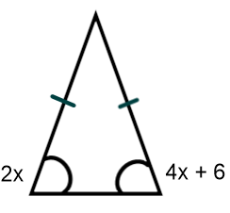
1. Given the isosceles triangle with two congruent angles, write an equation and solve for x.
Equation:
Solve:

2. Your total profit for mowing lawns this week is $24. You are paid $8 per hour and you paid $40 for gas for the lawnmower. How many hours did you work this week?
Equation:
Solve:

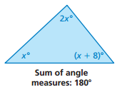
3. Write an equation to solve for the value of x.
Equation:
Solve:

4. Given the intersecting lines below, write an equation and solve to find the value of x. Then find the measure of each angle.
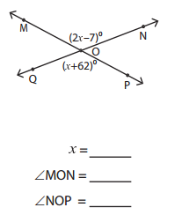
Equation:
Solve:

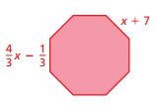
5. Given the regular polygon below, write an equation and solve to find the value of x. Then, find the perimeter of the polygon.
Equation:
Solve:

Perimeter = _________

6. One VIP movie club charges a $100 membership fee and $10 for each movie. Another club charges no membership fee but movies cost $15 each. Write and solve an equation to find the number of movies you need to buy for the cost of each movie club to be the same.
Equation:
Solve:

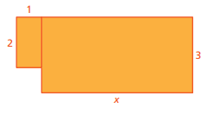
7. In the figure below, the value of the perimeter is equal to the value of the area. Write an equation that will allow you to solve for the value of x. Then, use “x” to find the perimeter and area.
a) Perimeter:

b) Area:

c) Equation:

d) Solve:

