Practice Quiz: 1.1-1.3 Absolute Value, Add and Subtract Integers

Name: ________________________________________ Period:_______
**No Calculators!

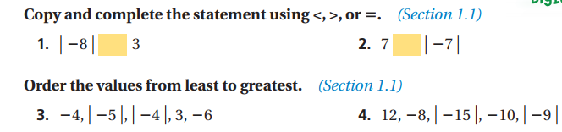

Write the solution to the problems below. Rewrite the problem if needed.

5. -14 + (-5) = 6. -22 + (-14) = 7. -8 + 3 =

8. 32 + (-12) = 9. -24 + (-9) + ( -16) = 10. -2 – (18) =

11. 18 – (-27) = 12. -125 – 93 = 13. 76 – (-286) =

14. -134 – (-33) = 15. 56 + (-23) – (-81) = 16. -49 – 17 + 22 =

17. The table shows the income and expenses for a school carnival. The school’s goal was to raise $1100. Did the school reach its goal? Explain.
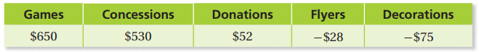

18. Temperatures in the Gobi Desert reach -40ͦ F in the winter and 90ͦ F in the summer. Find the range (difference between high and low values) of the temperatures.

19. Simplify: $\frac{11+14÷2}{3(8-2)}$ 20. Simplify: 4 [ 3 ● (58 – 49) – (14 – 12) ] + 7

