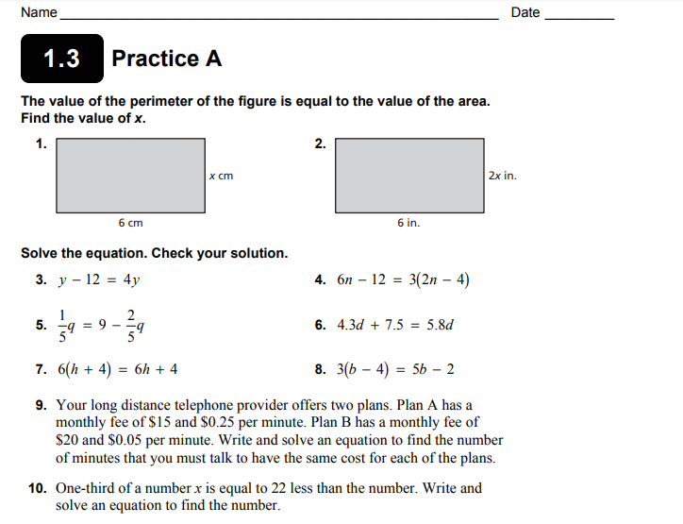

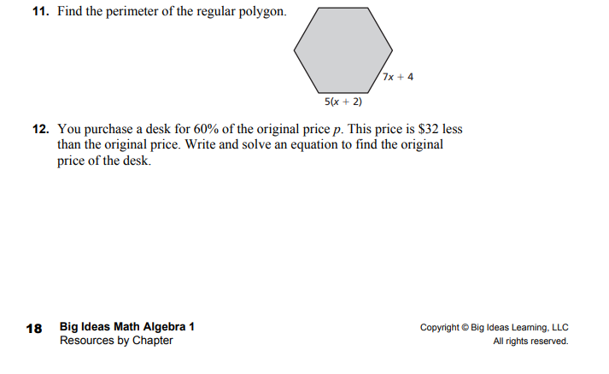

1) Equation:  Solve: | 2) Equation:  Solve:
3) Equation:  Solve: | 4) Equation:  Solve:
5) Equation:  Solve: | 6) Equation:  Solve:
7) Equation:  Solve: | 8) Equation:  Solve:
9) Equation:  Solve: | 10) Equation:  Solve:
11) Equation:  Solve: | 12) Equation:  Solve:

